**Topic:**

**Database Systems**

By:

|  |  |  |  |
| --- | --- | --- | --- |
|  | Name | Edu mail | B. N |
| 1 | **محمد خالد عبدالرسول أحمد** | **muhammed195779@feng.bu.edu.eg** | **699** |

GitHub-link: <https://github.com/muhammed-khalid/ece001>

GitHub Page: <https://muhammed-khalid.github.io/ece001/>

# Application Brief:

Databases today are essential to every business. Whenever you visit a major Web site -Google, Yahoo, Amazon, or thousands of smaller sites that provide information – there is a database behind the scenes serving up the information you request. Databases are likewise found at the core of many scientific investigation. The power of database comes from a body of knowledge and technology that has developed over several decades and is embodied in specialized soft were called a database management system, or DBMS, or more colloquially a "database system." A DBMS is a powerful tool for creating and managing large amounts of data efficiently and allowing it to persist over long periods of time, safely.

Database is nothing more than a collection of information that exists over a long period of time, often many years. In common parlance, the term database refers to a collection of data that is managed by a DBMS.

# Screenshots:

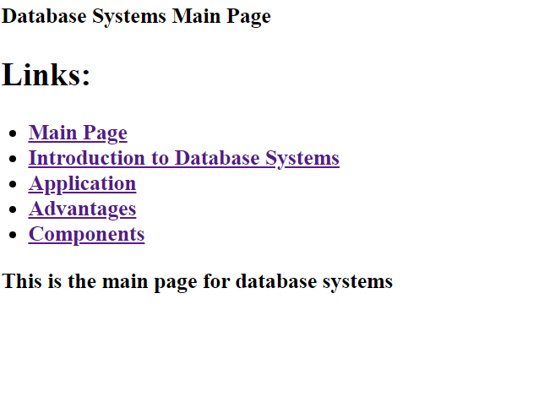

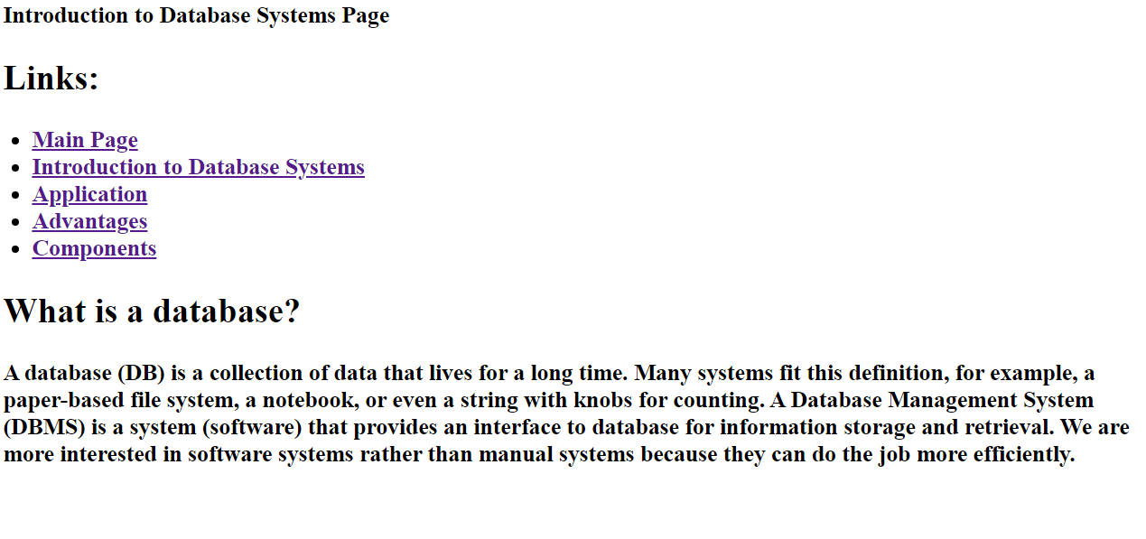

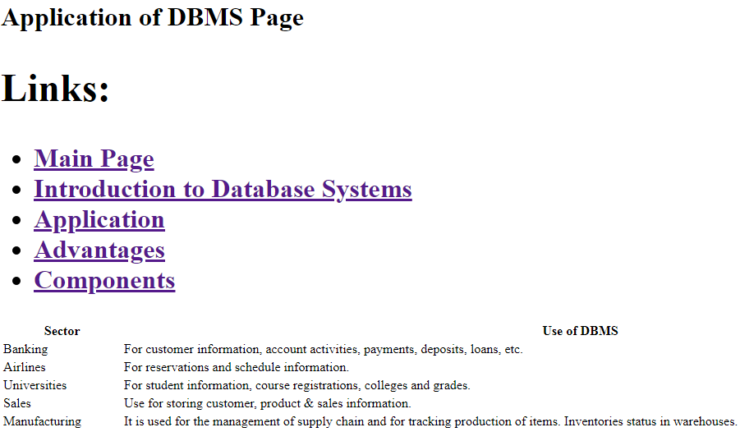

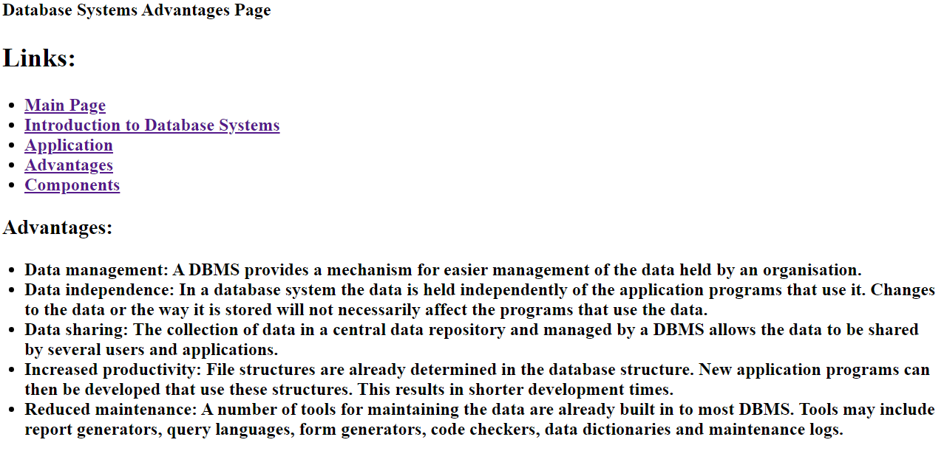

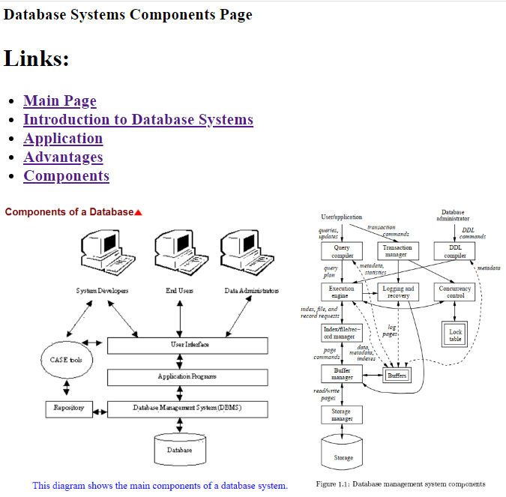

# Source Code:

